# **REFERENCE CHECKING SYSTEM**

## Problem Description:

Human Resource offices have always found it hard to handle enrolment of employees. This is due to the current enrolment systems adapted by organisations. One problem that overshadows all others is issue of reference checking. HR personnel have always found it a tedious task to verify applicant’s references.



An organization wants to streamline its reference checking process for potential job candidates. They aim to automate the process using an AI-powered technologies.

## Proposed Solution:

The proposed solution is a web-based application that assist the hiring team in evaluating a candidate's job-related skills, experience, and character through feedback from their references. The system allows the team to automate the reference check process, track the progress of each reference check, and generate reports on the feedback received from the candidate's references.

The system provides the following features and services:

1. Application Storage: The system will have the ability to store digital curriculum vitae as pdf documents, which will be later accessed by the HR team during interviews.
2. Reference Collection: The system will request contact information for references from candidates during the application process. It can be integrated into the organization's applicant tracking system (ATS) or operate as a standalone system.
3. Automated Reference Requests: The system will automatically send reference requests via email to the provided contacts. The email will include a unique link for each reference to access a secure online portal to provide feedback.
4. Standardized Questionnaire: The system will have a predefined set of questions for references to answer. These questions will be designed to gather relevant information about the candidate's skills, work ethic, strengths, weaknesses, and overall suitability for the position.
5. Natural Language Processing (NLP): The system will utilize NLP techniques to understand and analyse the responses provided by the references. It can extract key insights, sentiments, and patterns from the text data to generate valuable information for the hiring team.
6. Comparison and Ranking: The system can compare reference responses for multiple candidates to identify patterns and trends. It can generate rankings or scores based on the feedback received from different references, providing a quantitative measure of the candidate's suitability.
7. Integration with Applicant Evaluation: The reference checking system can integrate with the organization's applicant evaluation process. The insights generated from the reference feedback can be combined with other evaluation criteria (e.g., resumes, interviews, assessments) to provide a comprehensive view of each candidate.
8. Reporting and Visualization: The system can generate reports and visualizations summarizing the reference feedback and analysis. This allows the hiring team to quickly assess the information and make informed decisions about candidates.
9. Data Security and Compliance: The system will prioritize data security to protect the privacy and confidentiality of the references' information. It will comply with relevant data protection regulations and ensure that only authorized personnel can access the data

## Benefits:

1. Time Efficiency: Automating the reference checking process reduces the time and effort required from the HR team. The system can handle multiple reference requests simultaneously, accelerating the overall hiring timeline.
2. Objective Evaluation: The system provides a standardized approach to reference checking, ensuring consistent and fair evaluation of candidates. It minimizes biases that can arise from manual interpretation of reference responses.
3. Data-Driven Insights: The AI-powered analysis of reference responses generates valuable insights for the hiring team. It identifies trends, strengths, and areas of concern, enabling more informed decision-making.
4. Improved Candidate Quality: By collecting comprehensive reference feedback, the organization can make more accurate assessments of candidates' qualifications, reducing the risk of hiring mismatches.
5. Scalability: The reference checking system can scale effortlessly to accommodate a high volume of reference requests, making it suitable for organizations with diverse hiring needs.

## Proposed System’s level 2 DFD:

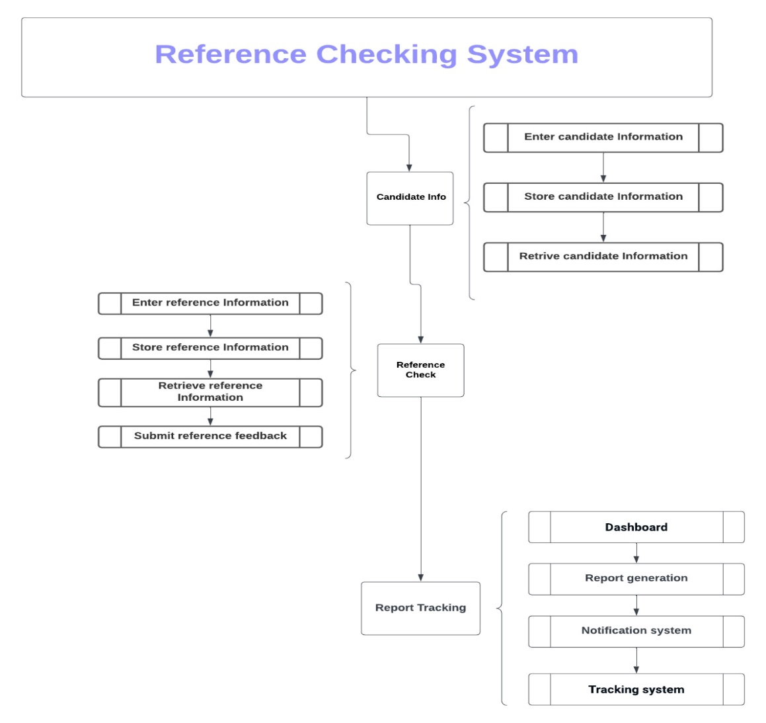

# Conclusion:

The Reference Checking System is an essential tool for any hiring team that wants to make informed hiring decisions based on feedback from the candidate's references. The system streamlines the reference check process, provides a comprehensive and objective evaluation of the candidate, and ensures compliance with legal requirements. By using the Reference Checking System, the hiring team can reduce the risk of hiring the wrong candidate and ensure that they make the best hiring decision for their organization.